

Travlr Getaways

# **CS 465 Project Software Design Document**

Version 1.0

## Table of Contents

**CS 465 Project Software Design Document** 1

Table of Contents 2

Document Revision History 2

Instructions 2

Executive Summary 3

Design Constraints 3

System Architecture View 3

Component Diagram 3

Sequence Diagram 4

Class Diagram 4

API Endpoints 4

The User Interface 4

## Document Revision History

| Version | Date | Author | Comments |
| --- | --- | --- | --- |
| 1.0 | 5/26/25 | April Nixon | Filled out the Executive Summary, Design Constraints, and System Architecture View sections |
| 1.0 | 6/8/2024 | April Nixon | Filled out Sequence Diagram, Class Diagram, and the API Endpoints table sections |

## Instructions

Fill in all bracketed information on page one (the cover page), in the Document Revision History table, and below each header. Under each header, remove the bracketed prompt and write your own paragraph response covering the indicated information.

**Executive Summary**

The Travlr Getaways web application will be developed entirely in JavaScript using the MEAN stack framework. This comprehensive approach utilizes MongoDB as the database for storing and managing all application data, allowing for seamless editing and entry additions by users. The backend structure and functionality will be built on Express.js, while Angular will be employed to enhance the application's front-end features and provide a streamlined administrative interface through a Single Page Application (SPA). Finally, the entire application will run on the Node.js server environment, ensuring efficient and scalable performance.

Or (in other words)

The Travlr Getaways project aims to develop a comprehensive full-stack web application using the MEAN stack (MongoDB, Express.js, Angular, Node.js) to manage travel-related data and interactions. This application will feature two main components: a customer-facing website and an admin single-page application (SPA).

The customer-facing website will allow users to browse and book travel packages, view travel itineraries, and access various travel-related services. The admin SPA will provide administrators with tools to manage travel packages, update travel information, and handle customer queries efficiently. This dual-component architecture ensures that both end-users and administrators have tailored interfaces to interact with the system effectively.

**Design Constraints**

When developing the Travlr Getaways web application, it's important to consider key design constraints. First, understanding customer preferences and feedback is important, as their approval will serve as a metric for design decisions. Second, careful scheduling is necessary to ensure the development process runs smoothly, avoids disrupting existing operations, and stays on track in terms of both timeline and budget.

Or (in other words)

Developing the Travlr Getaways application involves several design constraints that must be addressed to ensure a successful implementation. Firstly, scalability is an important concern as the application must handle a high volume of concurrent users, especially during peak travel seasons. This necessitates efficient database design and load balancing strategies to distribute traffic and prevent bottlenecks. Security is equally important, with a focus on protecting user data and ensuring secure transactions through authentication and authorization mechanisms to safeguard sensitive information.

Also, the application must deliver a seamless user experience with fast loading times and responsive interactions, requiring optimization of both frontend and backend performance. Compatibility across various devices and browsers is also essential to provide a consistent user experience regardless of the platform. These constraints will influence the development process by necessitating careful planning, comprehensive testing, and the implementation of best practices to meet the stringent performance, security, and scalability requirements.

**System Architecture View**

The overall system architecture of the Travlr Getaways web application consists of several interconnected components, which include the client-side, server-side, and database layers. On the client-side, the Angular application provides the user interface for both customers and administrators, facilitating interaction with the backend through RESTful APIs. This application runs in the user's browser, rendering the interface and enabling a smooth user experience. On the server-side, a Node.js server handles HTTP requests, serves the Angular application, and acts as the middle layer between the client-side and the database. The Express.js framework within the server aids in creating RESTful APIs, managing routing, and handling various backend functionalities.

The database layer employs MongoDB, a NoSQL database that stores essential travel-related data, including user information, travel packages, and bookings. This database offers flexibility in handling dynamic data structures, making it suitable for the application's needs. The Angular application communicates with the Node.js server via HTTP requests, which the server processes and uses to interact with the MongoDB database for data retrieval and updates. By leveraging the MEAN stack, the Travlr Getaways application enjoys a unified JavaScript-based development environment, ensuring seamless integration between the frontend and backend. This approach guarantees a robust, scalable, and high-performance application capable of meeting the needs of both end-users and administrators.

**Component Diagram**

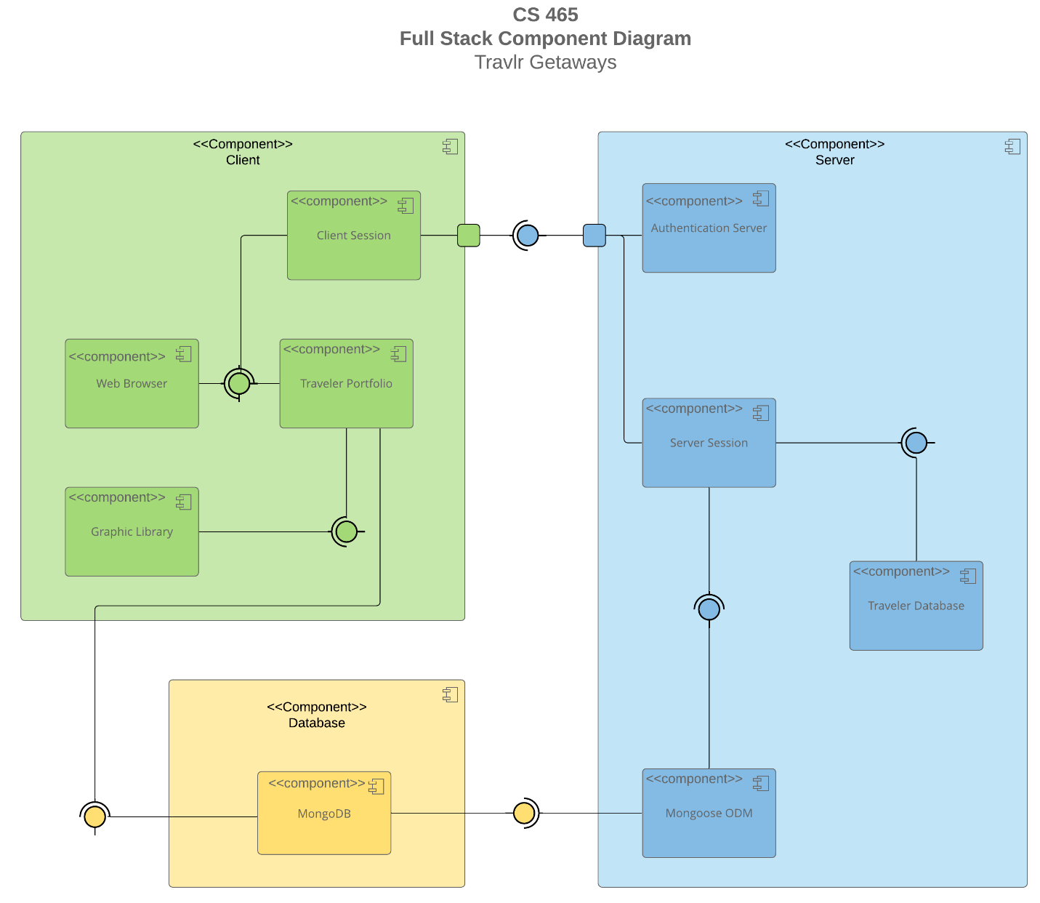

A text version of the component diagram is available: [CS 465 Full Stack Component Diagram Text Version](https://learn.snhu.edu/d2l/lor/viewer/view.d2l?ou=6606&loIdentId=24342).

The Travlr Getaways web application is built upon three core components: the client-side, server-side, and database. The database, specifically MongoDB, serves as the central repository for all application data, allowing for efficient storage, retrieval, modification, and deletion of information as needed. The client-side and server-side components work in tandem to deliver a seamless user experience.

The client-side, interacting with the user through a visually appealing and intuitive graphical interface, facilitates the browsing and consumption of information presented by the web application. It establishes a connection with the server-side through designated ports, enabling the exchange of data and requests.

On the server-side, the application leverages the power of Mongoose ODM (Object Data Modeling) to seamlessly communicate with the MongoDB database. This interaction is crucial for verifying user credentials, ensuring the security and integrity of data, and executing various operations on the stored information. The server-side acts as the bridge between the client-side and the database, processing requests, retrieving relevant data, and returning it to the client-side for display.

This modular architecture ensures a clear separation of concerns, making the application easier to maintain, scale, and update. The client-side focuses on delivering a user-friendly experience, while the server-side handles the complex logic of data management and interaction with the database.

### Sequence Diagram

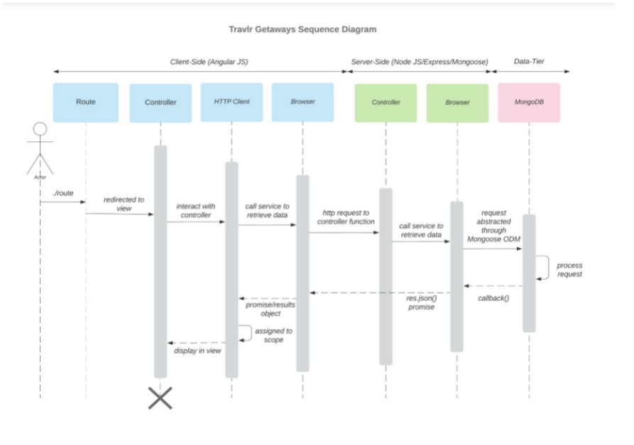

Above the diagram is showing the three key components, the client, the database and the

server. Beginning with the users’s computer we can then move to the view. The user would log in and

have access. The server side would then call to the website using MongoDB and it will connect with the

Travlr website. From there a scope is assigned and a view is displayed. The data will then deliver the

HTTP to the user.

Above the diagram is showing the three key components, the client, the database and the

server. Beginning with the users’s computer we can then move to the view. The user would log in and

have access. The server side would then call to the website using MongoDB and it will connect with the

Travlr website. From there a scope is assigned and a view is displayed. The data will then deliver the

HTTP to the user.

Above the diagram is showing the three key components, the client, the database and the

server. Beginning with the users’s computer we can then move to the view. The user would log in and

have access. The server side would then call to the website using MongoDB and it will connect with the

Travlr website. From there a scope is assigned and a view is displayed. The data will then deliver the

HTTP to the user.

Above the diagram shows the three key components, the client, the database and the server. Beginning with the users’ computer we can then move to the view. The user would log in and have access. The server side would then call to the website using MongoDB and it will connect with the Travlr website. From there a scope is assigned and a view is displayed. The data will then be delivered to the HTTP to the user.

## Class Diagram

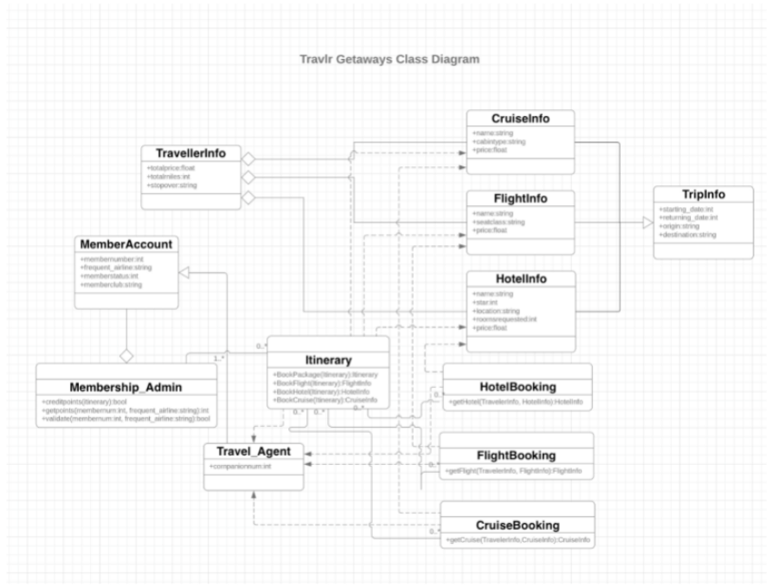

The class diagram shows us the different relationships between the classes. Each user will start out with a standard account but can get higher positions and higher roles within. The standard account role, for example, would be travel agents. The travel agents could use the itinerary to view the different items and interact with each of them.

The data for Flightlnfo, Cruiselnfo and Hotellnfo's data is stored within the Travellerlnfo. The data will then interact with the website and the website will show the site's information to the user when the user is interacting with the website.

## API Endpoints

| **Method** | **Purpose** | **URL** | **Notes** |
| --- | --- | --- | --- |
| **GET** | Retrieve list of trips | /api/trips | Returns all trips in database |
| **GET** | Retrieves a single trip | /api/trips/:tripCode | Returns a single trip that matches the code entered in the URL as a parameter |
| **POST** | Creates a new single trip | /api/trips | Creates a single new trip and adds it to the database |
| **PUT** | Updates a single existing trip's information | /api/trips:tripcode | Updates the information in the database of the trip specified by the code entered as a parameter |
| **DELETE** | Deletes a single existing trip | /api/trips:tripcode | Deletes the trip information in the database of the trip that matched the code passed as a parameter |
| **POST** | Creates a new user account | /api/register | Creates a single new user account based on the parameters passed through the form |
| **POST** | Creates a new JWT token for the user's session | /api/login | Creates a single new JWT authentication token for the user's session based on the parameters passed through the form and validation of the credentials |

## The User Interface

<Insert screenshots from the development of the SPA development to show the following: (1) a unique trip, added by you, (2) the Edit screen, and (3) the Update screen.>

<Summarize the Angular project structure and how it compares to the Express project structure. Be sure to describe the rich functionality provided by the SPA compared to a simple web application interaction. Describe the process of testing to make sure the SPA is working with the API to GET and PUT data in the database.>